EQT

(Expert Qualification TEST)

Nursing

We are glad to offer you this EQT to test your subject matter depth and formatting skills before taking you in our freelance expert writing team. This EQT contains a case study and based on that there are questions, which you need to answer.

Important Note
- Before attempting EQT solution, you have to download Writing Methodology docket which contains 8 documents numbered as Doc1, Doc2 and so on.
Link to download this Docket: http://mywritingmaster.in/expert-qualification-test/

- Your EQT solution will Judged based on
- Application of Bloom’s taxonomy (Check Doc 3)
- Plagiarism (Plagiarism (Copy pasting from external sources) is a strict offense in foreign universities. Your EQT solution will undergo Turnitin Software check, which can catch plagiarism not only from internet content, but also from journals or even assignments submitted by students as assignments in their universities) (Check Doc 4)
- Referencing (Check Doc 1 and Doc 2)
- Assignment Formatting (Check Doc 6)
- Depth of subject knowledge
- English proficiency

- Your final solution should look like this : (Check Doc 5)

- Word limit and Deadline for EQT
- Word limit: 1000 words
- Deadline : 72 hours from the date of sharing EQT

Case study
Read carefully the guidelines as well as understand the concept of Bloom’s Taxonomy before attempting to write the solution. When assessing your solution your subject based knowledge, capability to align understanding with the requirement, bloom’s understanding and application in writing would be checked along with grammar and spellings.

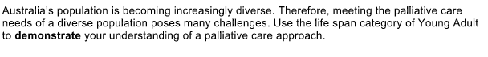
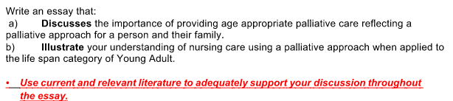

Marking Rubrics is given below. Any assignment solution is graded using the Marking rubrics. Please prepare the solution which meets all the requirements stated below in the marketing rubric for this nursing assignment.

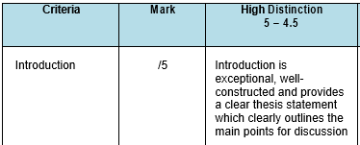

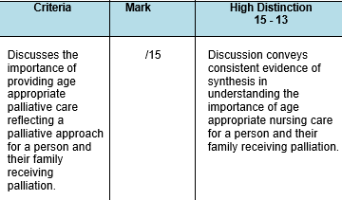
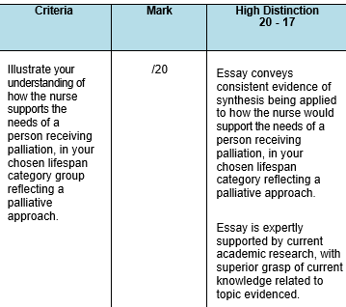
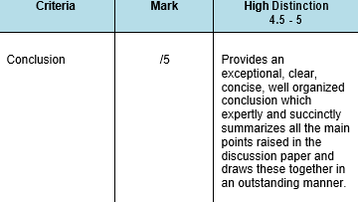
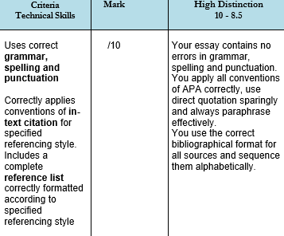

Which Bloom’s category of does each of these questions belong to?

Assignment Task | Cognitive Skills Exercised(from Bloom’s) | Marks Allocation
- Discuss the importance of providing age appropriate palliative care reflecting a palliative approach for a person and their family. | Understanding, Application | 25marks
- Illustrate your understanding of nursing care using a palliative approach when applied to the life span category of Young Adult. | Analysis, Application | 35marks

Please distribute the total word count, which is 1000 words, in proportion to the weightage of marks allotted to each of the sub-sections. Also, use in-text as well as reference list to substantiate your answers. The referencing style suggested is Harvard AGPS and auto referencing is suggested to be used.

The above table shows the level of Blooms that is required to be considered in different sections while writing the solution. Make sure to understand the concept of bloom and how you need to incorporate blooms level of cognitive writing when writing your solution. Feel free to get back to us for any clarification or understanding.

Your solution won’t be marked and accepted for candidature if you fail to incorporate the cognitive writing abilities, as per bloom, in your solution.

---------All the best---------

