MWM Problem solving competition

Wireless and Internet Technology

Exercise 1
Investigate the history of the CSIRO Wifi patent which was recently up-held in courts in the United States. This patent covers significant aspects of the OFDM implementation which is used in modern Wifi devices, 3rd and 4th generation mobile phones, and also wired communication.
You should investigate the development of OFDM, and the CSIRO patent, and in particular, answer the following questions:
- When was the CSIRO patent applied for and in which countries
- When will it cease to apply? Are the dates different in different countries, and if so what are some examples of differences?
- Which firms have agreed to license the technology from the CSIRO and how much have they agreed to pay?
- What was the most important aspect of the CSIRO patent?
- When was the term OFDM first used to describe this approach to wireless transmission?
- Are other parties also credited with the invention of aspects of OFDM (and if so, who are they, and what was their contribution)?
- Which modern wireless technologies use OFDM?

Exercise 2
This exercise is the one name as Exercise 3.5 in the study book. This exercise is about the length of the symbol used to transmit a single bit, on a sub-channel, using OFDM, compared with the duration of a single bit when the symbol for a bit is transmitted on the channel directly by means of a modulation scheme like PSK or FSK.

Exercise 3

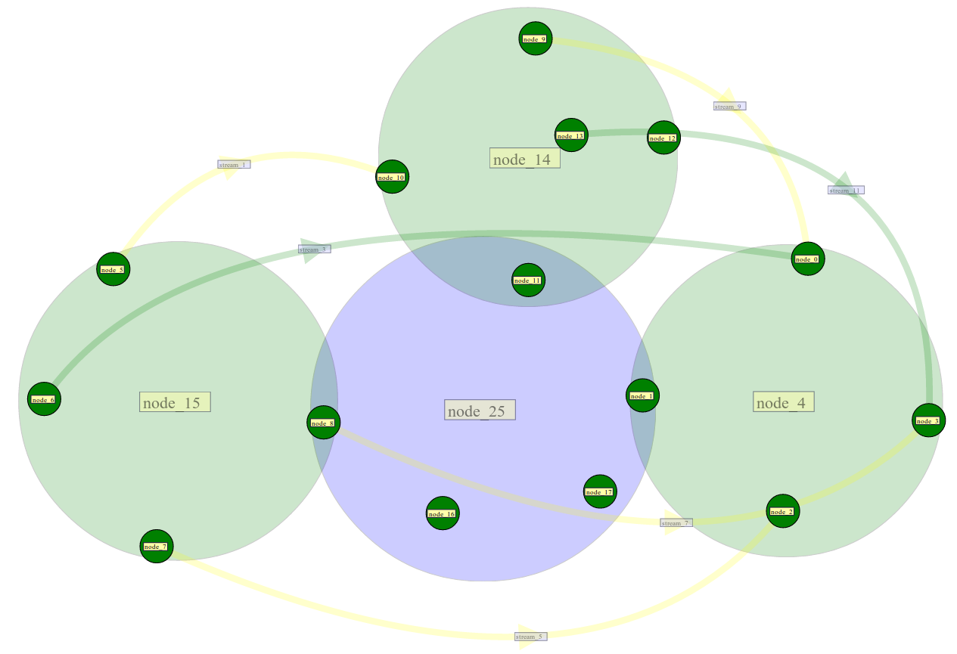
Create and simulate a network with three 802.11a wireless networks, A, B, and C, joined by a CSMA LAN, as depicted in the diagram. The LAN should have a capacity of 10 Mbps and a propagation delay of 10 microseconds.
There should also be 6 traffic streams, three from one node to another within a wifi domain, and three from a node in one wifi domain to a node in a different wifi domain. These should all be ftp flows, with randomised start times and either 1,000,000 bytes in the flow or 10,000,000, half each, but making sure that at least one of the larger flows is goes from one wifi domain to another and at least one goes from a node in one wifi domain to another node in the same domain.
Run a series of simulations with different settings for the capacity and propagation delay of the LAN: with capacities ranging from 1 Mbps, to 1 Gbps, and propagation delays ranging from 1 microsecond to 100 milliseconds.
In your answer, explain how the behaviour of the network changes as the capacity and delay of the LAN changes. Use graphs to illustrate your observation of the network. Focus on the following issue: is it possible for the traffic between one wifi domain and another to achieve performance as good as traffic within a domain, if the network between the domains is fast enough?

Criteria
In the answer to Exercise 1, answers to the question 1-3 about the patent have been provided to the questions asked, and these are supported by references which support the proposed answers.
In the answer to Exercise 1, answers to the question 4-6 about the patent have been provided to the questions asked, and these are supported by references which support the proposed answers.
In the answer to Exercise 1, answers to the question 7 about the patent have been provided to the questions asked, and they are supported by references which support the proposed answers.
In the answer to Exercise 2, the duration of one bit in a two-phase modulated system and in the system using 1024 sub-channel OFDM has been calculated, with calculations shown, and is correct.
In the answer to Exercise 2, the number of periods (cycles) of the basic frequency which occur in the PSK system and in the sub-channels of the OFDM system has been calculated, the calculations are shown and the result is correct.
In the answer to Exercise 2, the % of overlap for a single bit has been calculated in the two systems, the calculations are shown, and the result is correct.
In the answer to Exercise 3, a diagram of the network being simulated has been included in the assignment
In the answer to Exercise 3, plots of the throughput of the traffic in different scenarios (in regard to the pt-to-pt links) have been presented.
In the answer to Exercise 3, a well argued conclusion with regard to the effect of increasing the capacity of the pt-to-pt links has been presented

